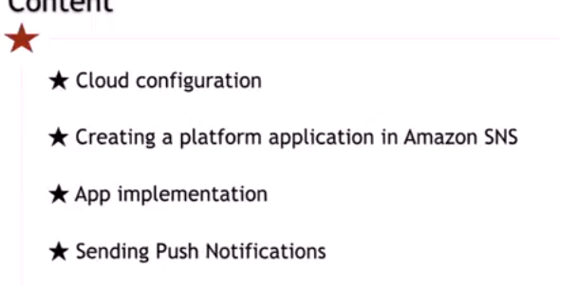

1. Setup the application in Google and Firebase – CREATE A PROJECT IN GOOGLE DEVELOPER CONSOLE. iMPORT THAT PROJECT TO FIREBASE )IMPORT FROM GOOGLE OPTION)

SETTING->CLOUD MESSAGING -SERVER KEY & SENDER ID

1. Setup SNS Platform Application in SNS Console - AMAZON WEB SERVICE(SNS)

CHOOSE SNS

APPLICATION->CREATE PLATFORM APPLICATION-APP NAME

PLATFORM – GOOGLE CLOUD MESSAGING(GCM)

API KEY – PASTE SERVER KEY

1. App implementation – ADD PHONEGAP PLUGIN WITH FIREBASE SENDER ID

INCLUDE PUSH NOTIFICATIONFACTORY

AMAZON SNS CONSOLE – APPLICATION – CREATE PLATFORM ENDPOINT -PASTE DEVICE TOKEN FROM CONSOLE

CLICK PUBLISH TO ENDPOINT

JSON FORMAT – TYPE MESSAGE- SEND

4. Send and Test the Push Notification from SNS.

